1. **OBJECTIVES**

See the final requirements document.

1. **HARDWARE DESIGN**

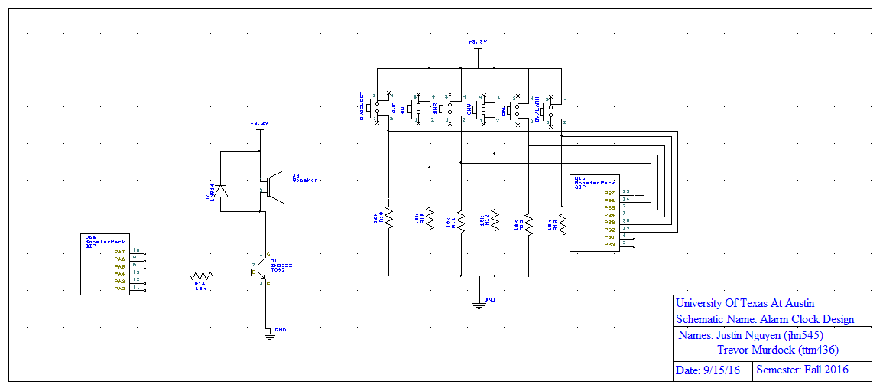

*Figure 1: PCB layout of our alarm clock. 6 switches (left, right, up, down, select, alarm).*

*Speaker circuit is also shown. See the .sch file for details/better view.*

1. **SOFTWARE DESIGN**

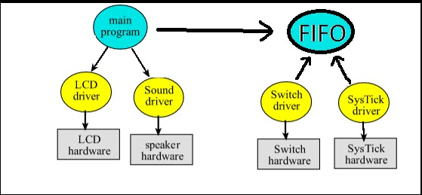

*Figure 2: call graph*

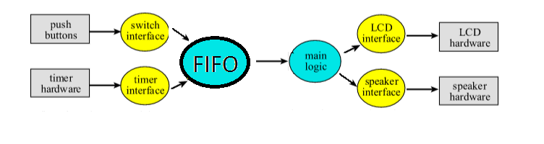

*Figure 3: Data Flow Diagram*

1. **MEASUREMENT DATA**

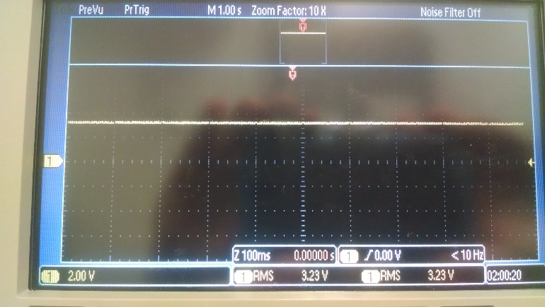

*Figure 4: 3.3 RMS magnitude of supply voltage versus time*

***4.2***

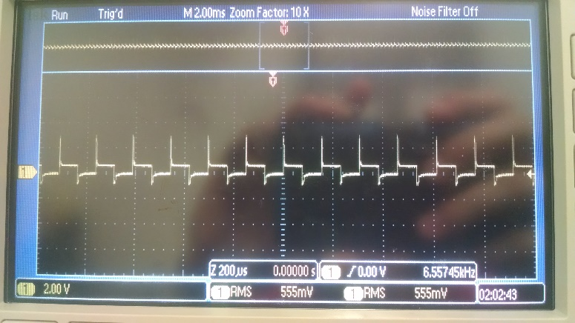

*Figure 5: Speaker voltage during an alarm*

***4.3***

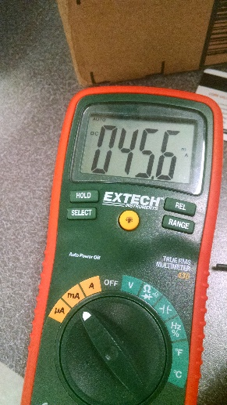

*Figure 6: Current required to run the alarm clock with the speaker on*

***4.4***

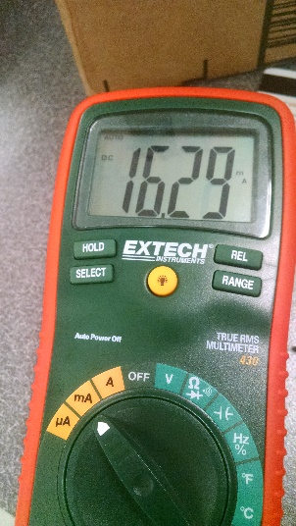

*Figure 7: Current required to run the alarm clock with the speaker off*

1. **ANALYSIS AND DISCUSSION**

**5.1 Give two ways to remove a critical section.**

You can use friendly code (bit specific addressing) or use a communication queue like a FIFO. A bad way to remove a critical section is to disable interrupts.

**5.2 How long does it take to update the LCD with a new time?**

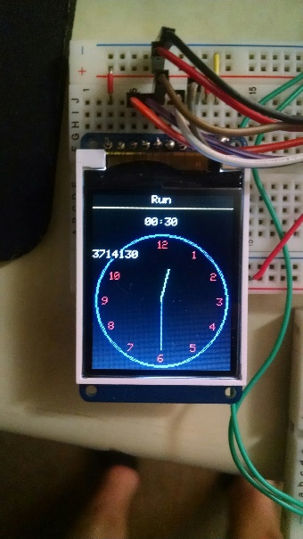

*Figure 8: It takes 0.23 seconds to update the LCD with a new time. It is very slow because we changed the bus clock from 80MHz to 16MHz. We did this because we were using SysTick and the data register in SysTick only has 24 bits. Even when maxed out, interrupts would occur every 0.2 seconds, which was often enough that it prevented our clock from running in real time (it was off by 7-8 seconds per minute). We didn’t realize that the timers had 32 bit registers, so we decided to slow down our bus clock (making each tick approximately 5 times slower so that the SysTick data register counted to zero every 1.0486 seconds). In the end it “worked” in the sense that our system ran in real time, but it made our screen flicker and draw everything much slower. It was a hack due to our lack of knowledge about timers vs. SysTick.*

**5.3 What is the disadvantage of updating the LCD in the background ISR?**

The time it takes to return to the main would be too long and increase the chance of critical sections. A long ISR could cause the system’s timing to be off and the system wouldn’t be real time.

**5.4 Did you redraw the entire clock for each output? If so, how could you have**

**redesigned the LCD update to run much faster, and create a lot less flicker?**

We did not redraw the entire clock, but we did redraw both the hour hand and

minute hand. We could only redraw the hands when they are supposed to move.

* 1. **Assuming the system was battery powered, list three ways you could have**

**saved power.**

You could decrease the interrupt frequency (perhaps from every second to every

minute), only update the screen when needed, or use a speaker with a higher resistance (this will lower the volume) and decrease the frequency of the alarm.